Exercise 1 : Project Initialization and First Commit

Scenario:
You’ve joined a new software development team as a frontend developer. Before working on any features, your team lead asks you to set up version control for your project and make your first commit with the initial web page.

Tasks:
- Install Git and configure your name and email.

^{git —version}
git config –global user.name “Harshitha Reddy”
git config –global user.email “ harssshhhhhhh@gamil.com”
^{git config –list}
2. Create a local Git repository using git init.
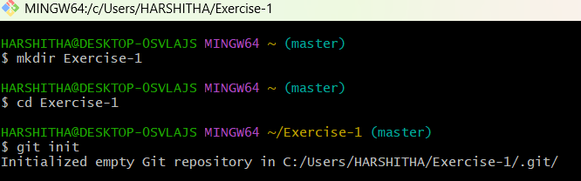

- Create a basic index.html file that displays your name, title, and a short paragraph
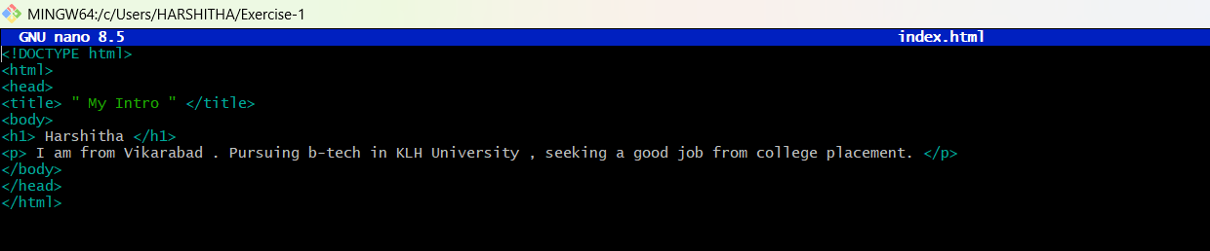

4. Track the file using git add and commit it using git commit -m "Initial commit with HTML structure".
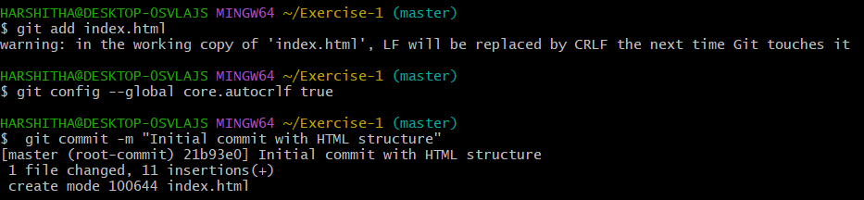
- View the commit history using git log.
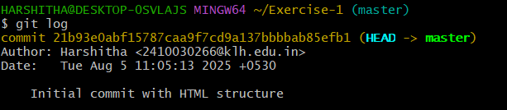

^{Expected Output:}
• A Git repository with 1 committed HTML file.
• A screenshot of the commit log.
